Finite Word length Effects
6.2 Analysis of Finite Word Length Effects in Digital Signal Representation Using Truncation Rounding Techniques in MATLAB

Program (MATLAB Code)
clc; clear; close all
n=0:79;
x=sin(2*pi*n/40);
q=8;
xt=floor(x*q)/q;
xr=round(x*q)/q;
et=x-xt;
er=x-xr;
% Fig 1
figure
plot(n,x,'b',n,xr,'r','LineWidth',1.5)
grid on
title('Original vs Quantized')
legend('Original','Quantized')
% Fig 2
figure
plot(n,x,'b',n,xt,'r',n,xr,'g','LineWidth',1.5)
grid on
title('Truncation vs Rounding')
legend('Original','Truncated','Rounded')
% Fig 3
figure
stem(n,et,'r')
hold on
stem(n,er,'g')
grid on
title('Quantization Error')
legend('Truncation','Rounding')
% Fig 4
figure
bar([mean(et.^2) mean(er.^2)])
set(gca,'XTickLabel',{'Truncation','Rounding'})
grid on
title('MSE Comparison')
ylabel('MSE')
Output

Fig 1
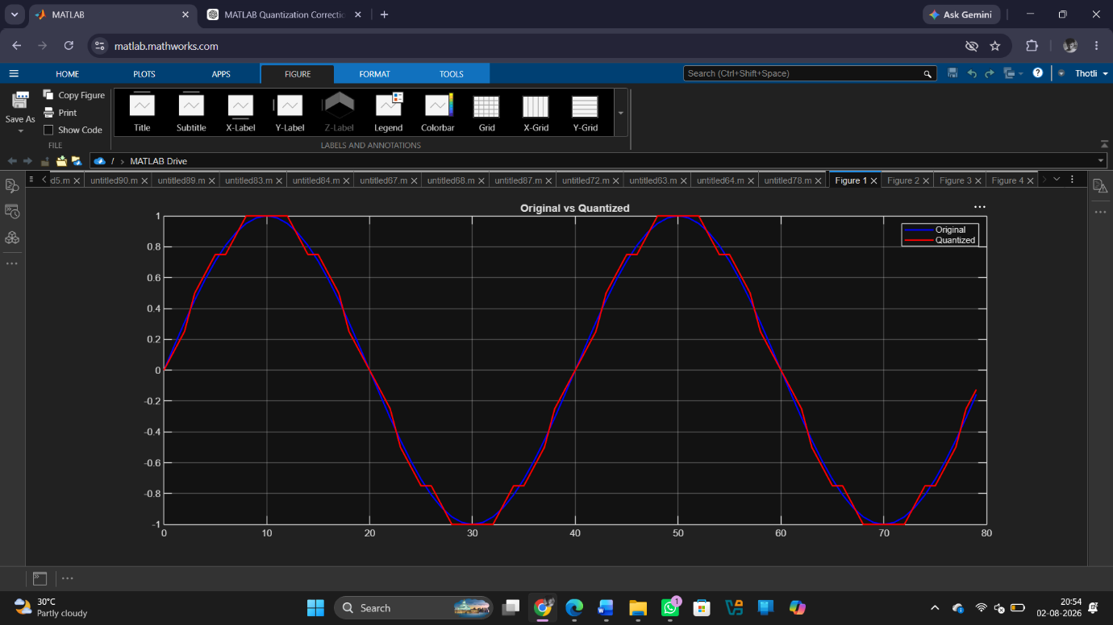

Fig 2

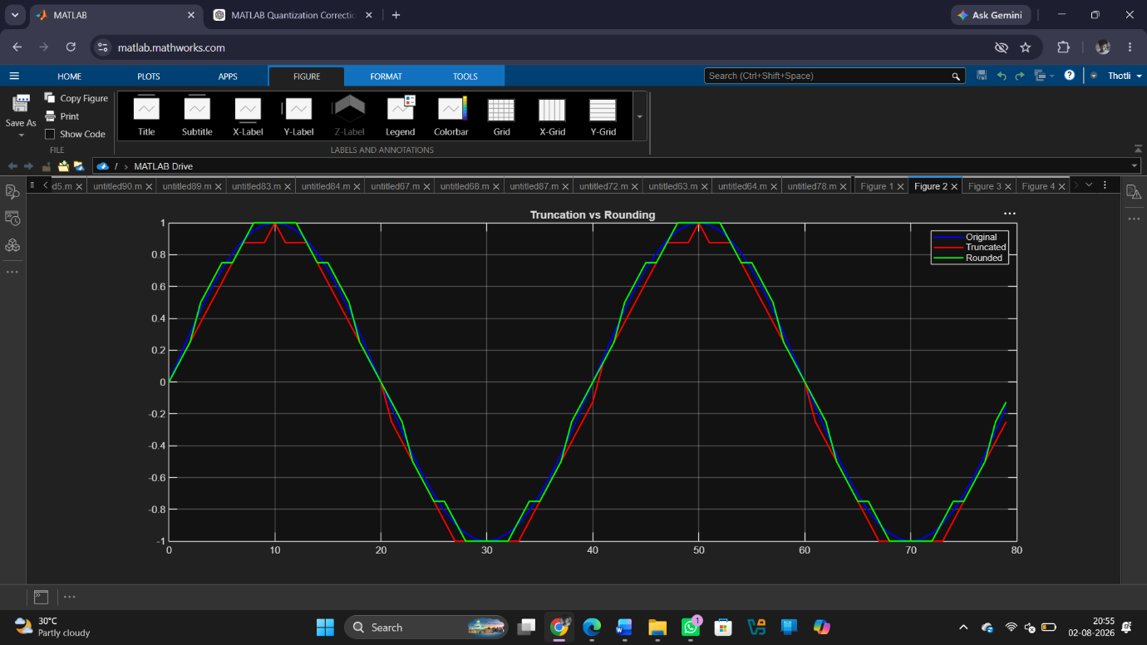

Fig 3
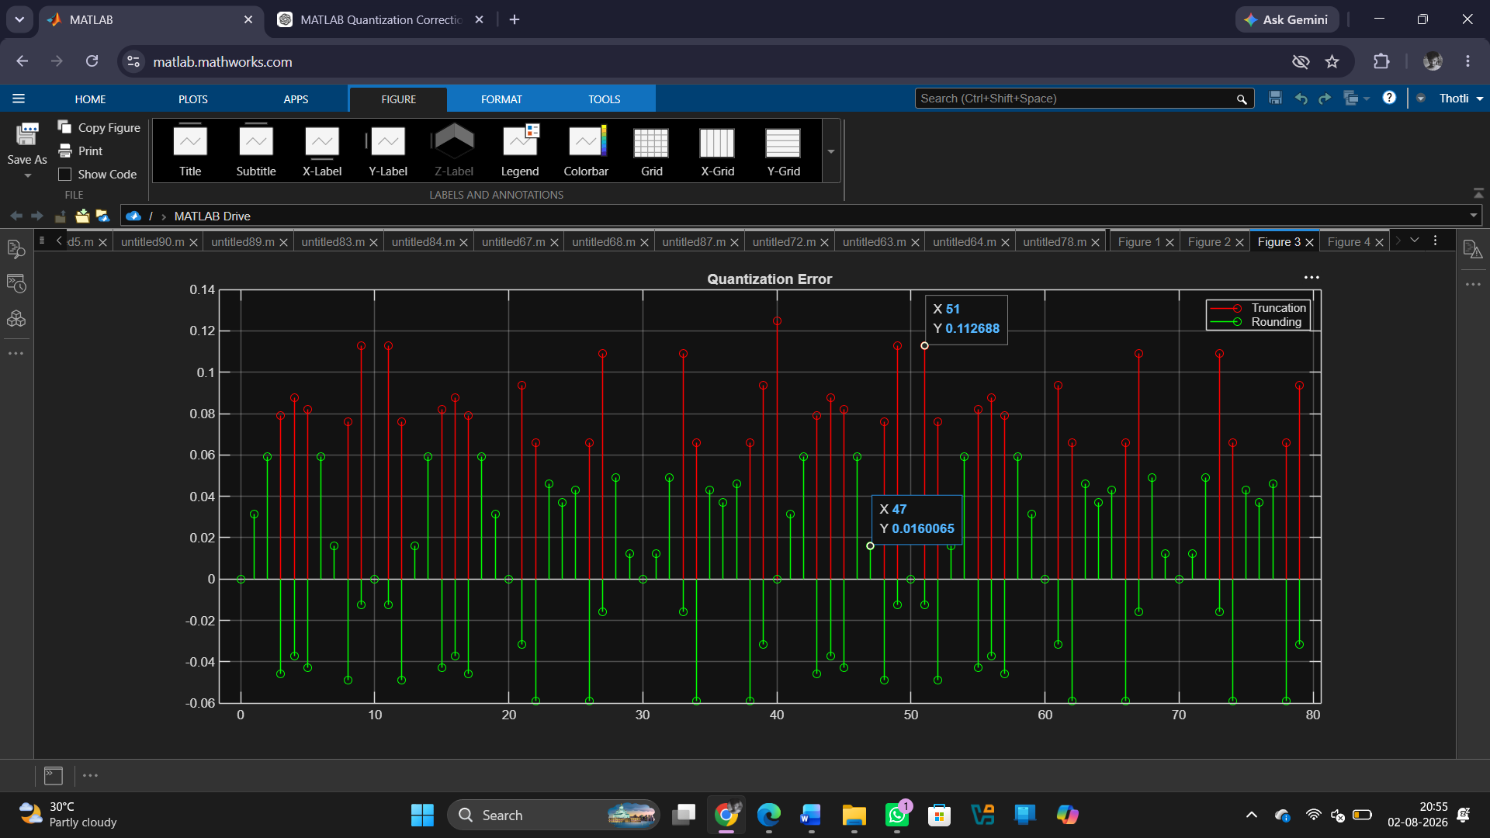

Fig 4
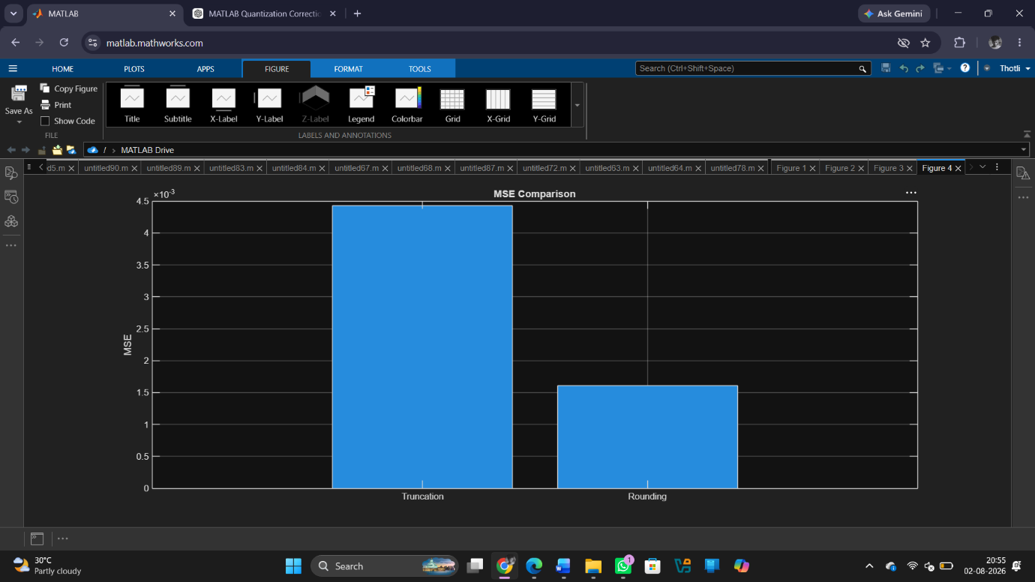

Result
1. The digital signal was successfully represented using a finite word length format in MATLAB.
2. Truncation and rounding operations were implemented on the signal samples.
3. The errors introduced by truncation and rounding were computed and compared, showing that rounding generally produces smaller errors than truncation.
4. The effect of finite precision on signal representation was analysed, demonstrating that reduced word length increases representation error and may affect signal accuracy.

